Show_plot_compare_strategies

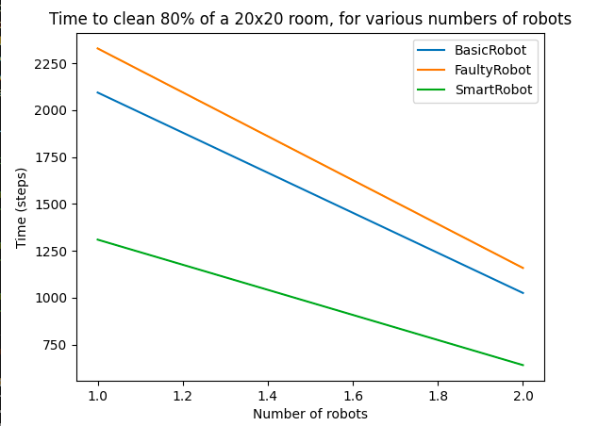

Show_plot_room_shape

